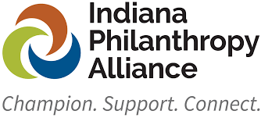
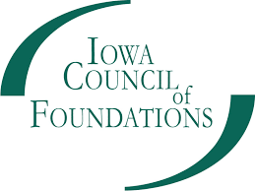
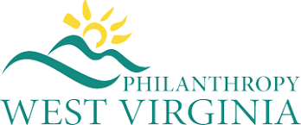
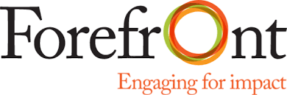
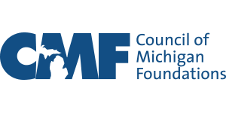

Post-Graduation Scholarships (H.R. 3582)

Post-graduation scholarships address both the student debt crisis and the economic stagnation in many of the nation’s rural communities and can be a powerful tool for philanthropy. Post-graduation scholarships, like traditional scholarships, help offset some of the costs of obtaining a degree or technical education, while targeting specific skill sets needed in certain regions, as determined by the foundations that serve those regions. These scholarships allow community leaders to identify and meet local needs.

Legislative action is needed to make post-graduation scholarships tax free to the recipient, like traditional scholarships. Eliminating the tax burden on graduates receiving a post-graduation scholarship will further increase the impact that foundations can have in addressing student debt and stimulating regional economic growth in their communities.

State of Play
The Workforce Development Through Post-Graduation Scholarships Act would define post-graduation scholarship grants as a charitable activity, making them tax-free to the recipient, and establish eligibility requirements to ensure post-graduation scholarships benefit communities most in need of skilled workers.

The legislation is being re-introduced by Senators Gary Peters (D-MI) and Shelley Moore-Capito (R-WV) and Reps. Darin LaHood (R-IL) and Terri Sewell (D-AL).

Background
The student debt crisis is one of the many pressing issues affecting economic advancement for families and communities across the country. This, coupled with the rising cost of post-secondary attainment, exacerbates the difficulties communities are facing to attract and retain the skilled workers necessary to maintain infrastructure and meet the demands of the modern economy.

A post-graduation scholarship is a creative idea intended to ease student debt while retaining talent in specific communities. Under current law, grants made to students to help pay off educational loans are taxable to the student. The Workforce Development Through Post-Graduation Scholarships legislation will allow 501(c)3 charitable organizations to pay off a student's loan from a recently completed degree or technical program with no tax impact on the student, similar to traditional scholarships.

Nonprofit employers, like other sectors, are experiencing unprecedented workforce challenges. Similarly, communities across the nation are grappling to address workforce shortages and find candidates, which results in fewer services being available for residents everywhere. This may be especially true in rural areas. At the same time, student debt is mounting, while remaining concentrated among borrowers with zero or negative wealth. At this nexus of workforce shortage and student debt, post-graduation scholarships may offer a mitigating strategy. A post-graduation scholarship is a type of charitable grant that foundations may make to attract individuals with career skills needed in a particular region to make their homes and build their careers in that community.

Post-grad scholarships will stimulate regional economic growth and help address the growing student debt crisis.

This bill defines post-graduation scholarship grants as a charitable activity and excludes post-graduation scholarship grants from the recipient individual’s taxable income. A post-graduation scholarship would be awarded to an individual who has already completed a degree or technical program in a career field that is needed in a particular region, thus paying off a portion of the individual’s student loans. As with traditional scholarships, these programs would establish eligibility requirements, as well as a process to verify that those requirements continue to be met through the duration of the scholarship award agreement. The scholarships would be administered by place-based foundations that are well-positioned to facilitate the matching process among donors, recipients, and employers; scholarship funds would be paid directly to the lender (not the individual).

The proposal is modeled after successful local programs in Michigan,^{[1]} is supported by the Council on Foundations and the Alliance of Illinois Community Foundations, and builds upon the adoption of HR26 by the Illinois legislature in 2021.

^{[1]} See https://www.stclairfoundation.org/come-home-award/ and http://www.cfcrawford.org/come-home-scholarship

